NAMA : IVAN FAUSTA DINATA (V3920030)

KRESHNA PUTRA ADI WICAKSANA (V3920032)

KELAS : TI-D

MATAKULIAH : PEMROGRAMAN BACKEND

LINK GITHUB : -

-<https://github.com/kreshna3131/Backend_Form>

Application/views/admin/mahasiswa/new_form.php

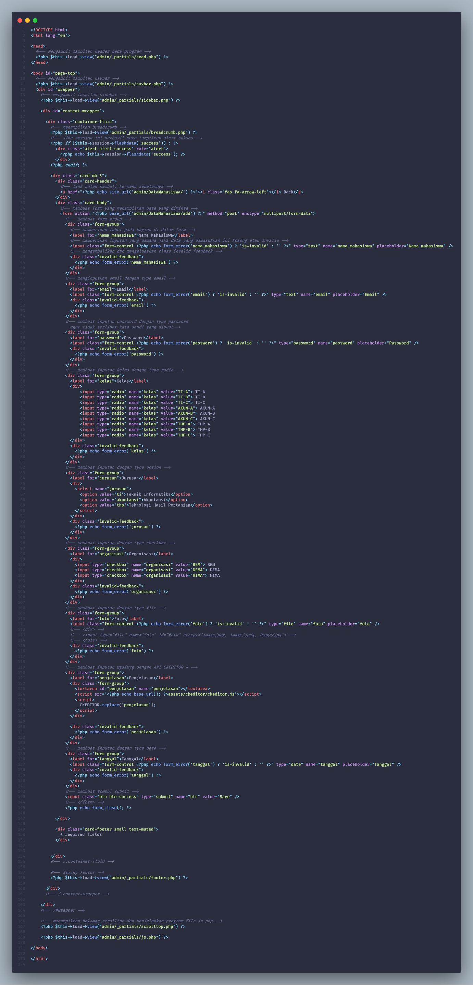

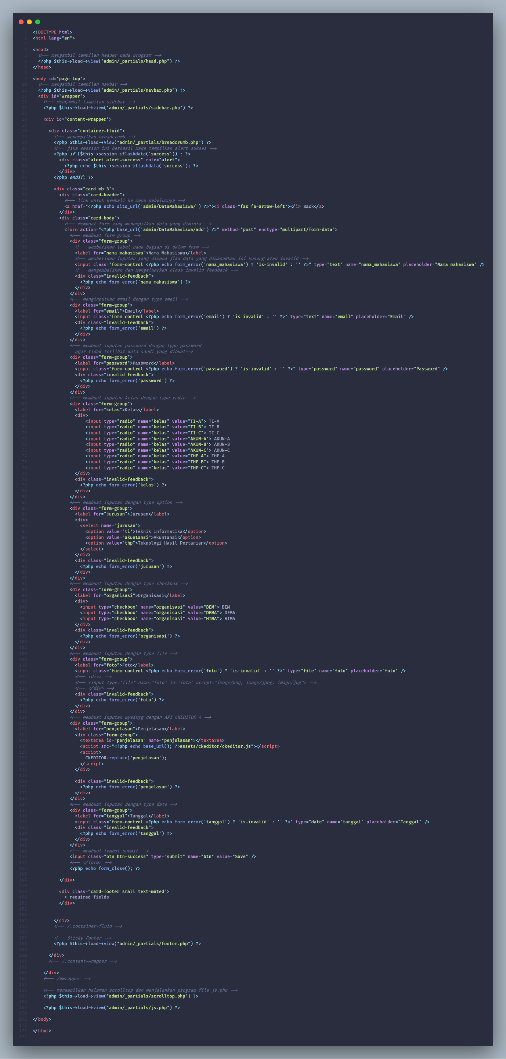

Application/views/admin/mahasiswa/list.php

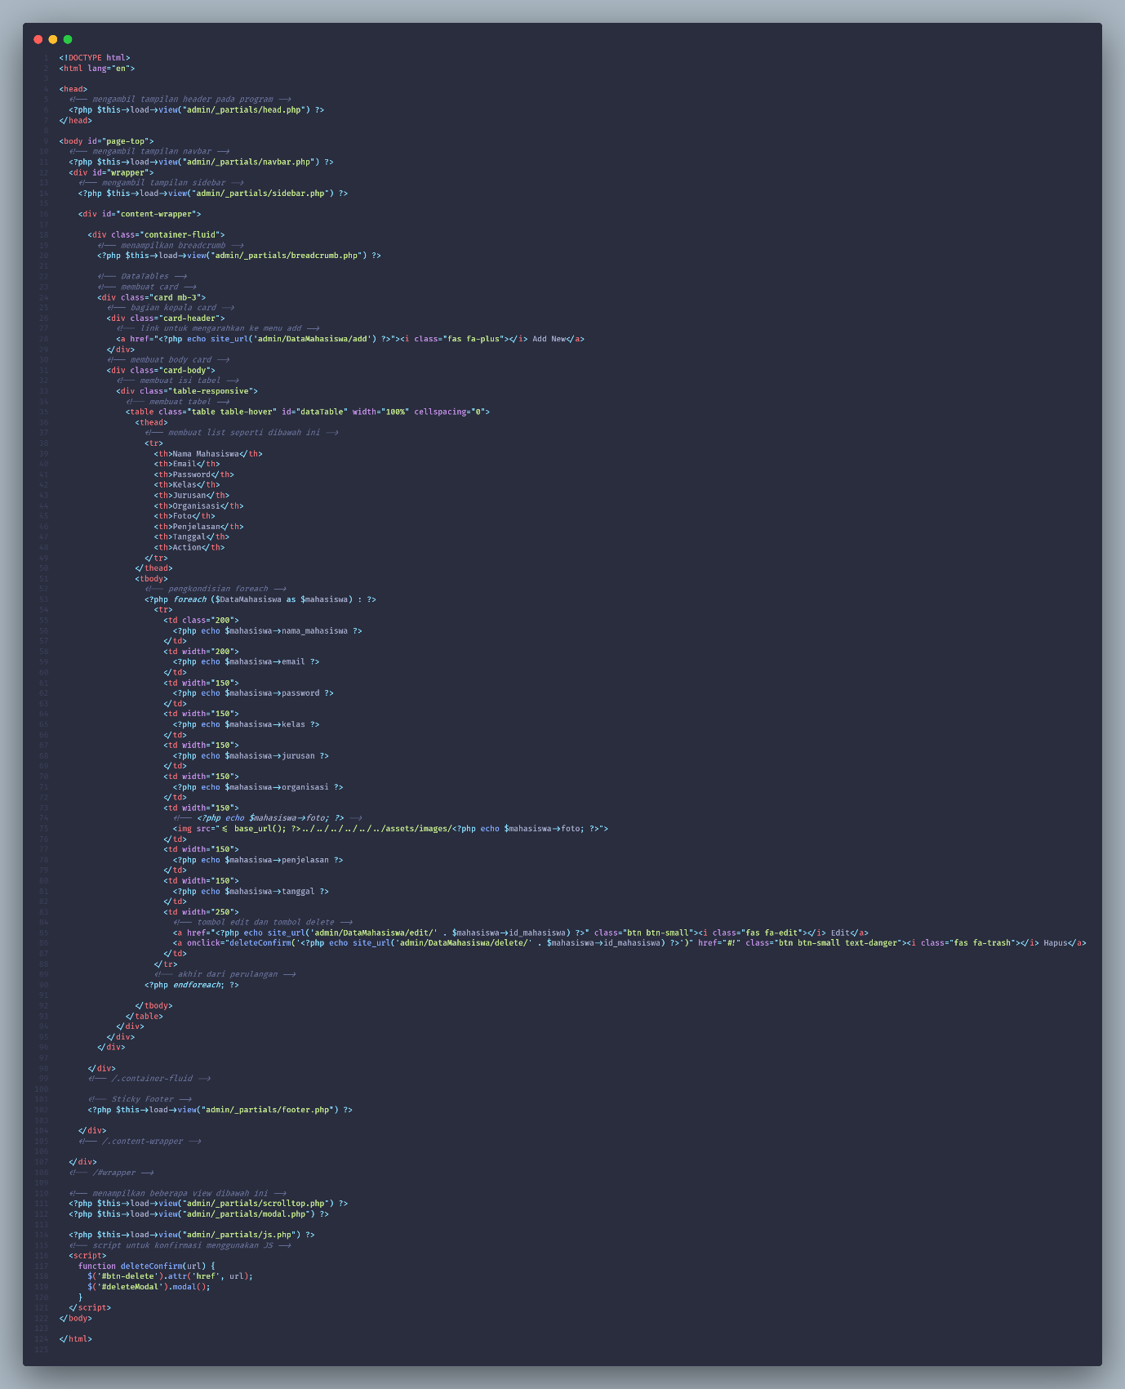

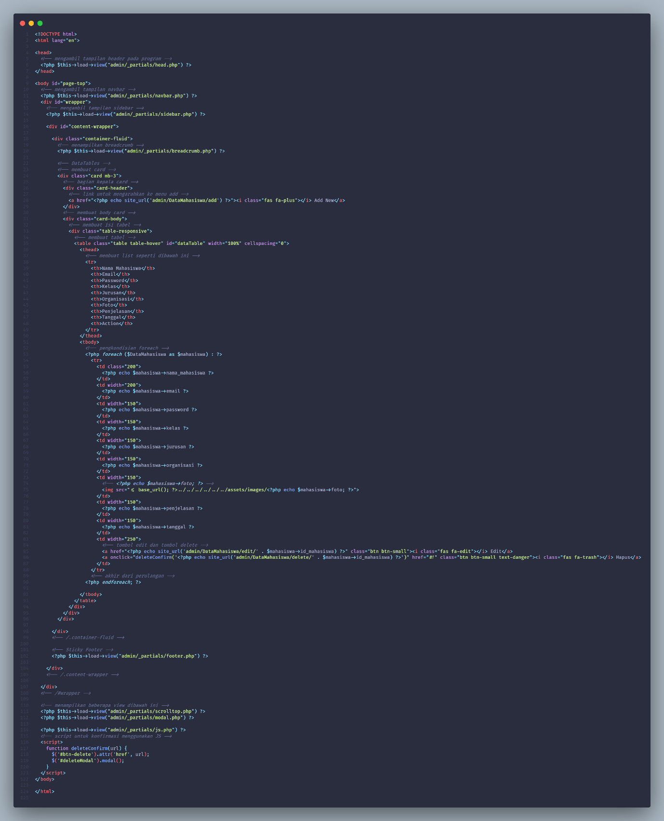

Application/views/admin/mahasiswa/edit_form.php

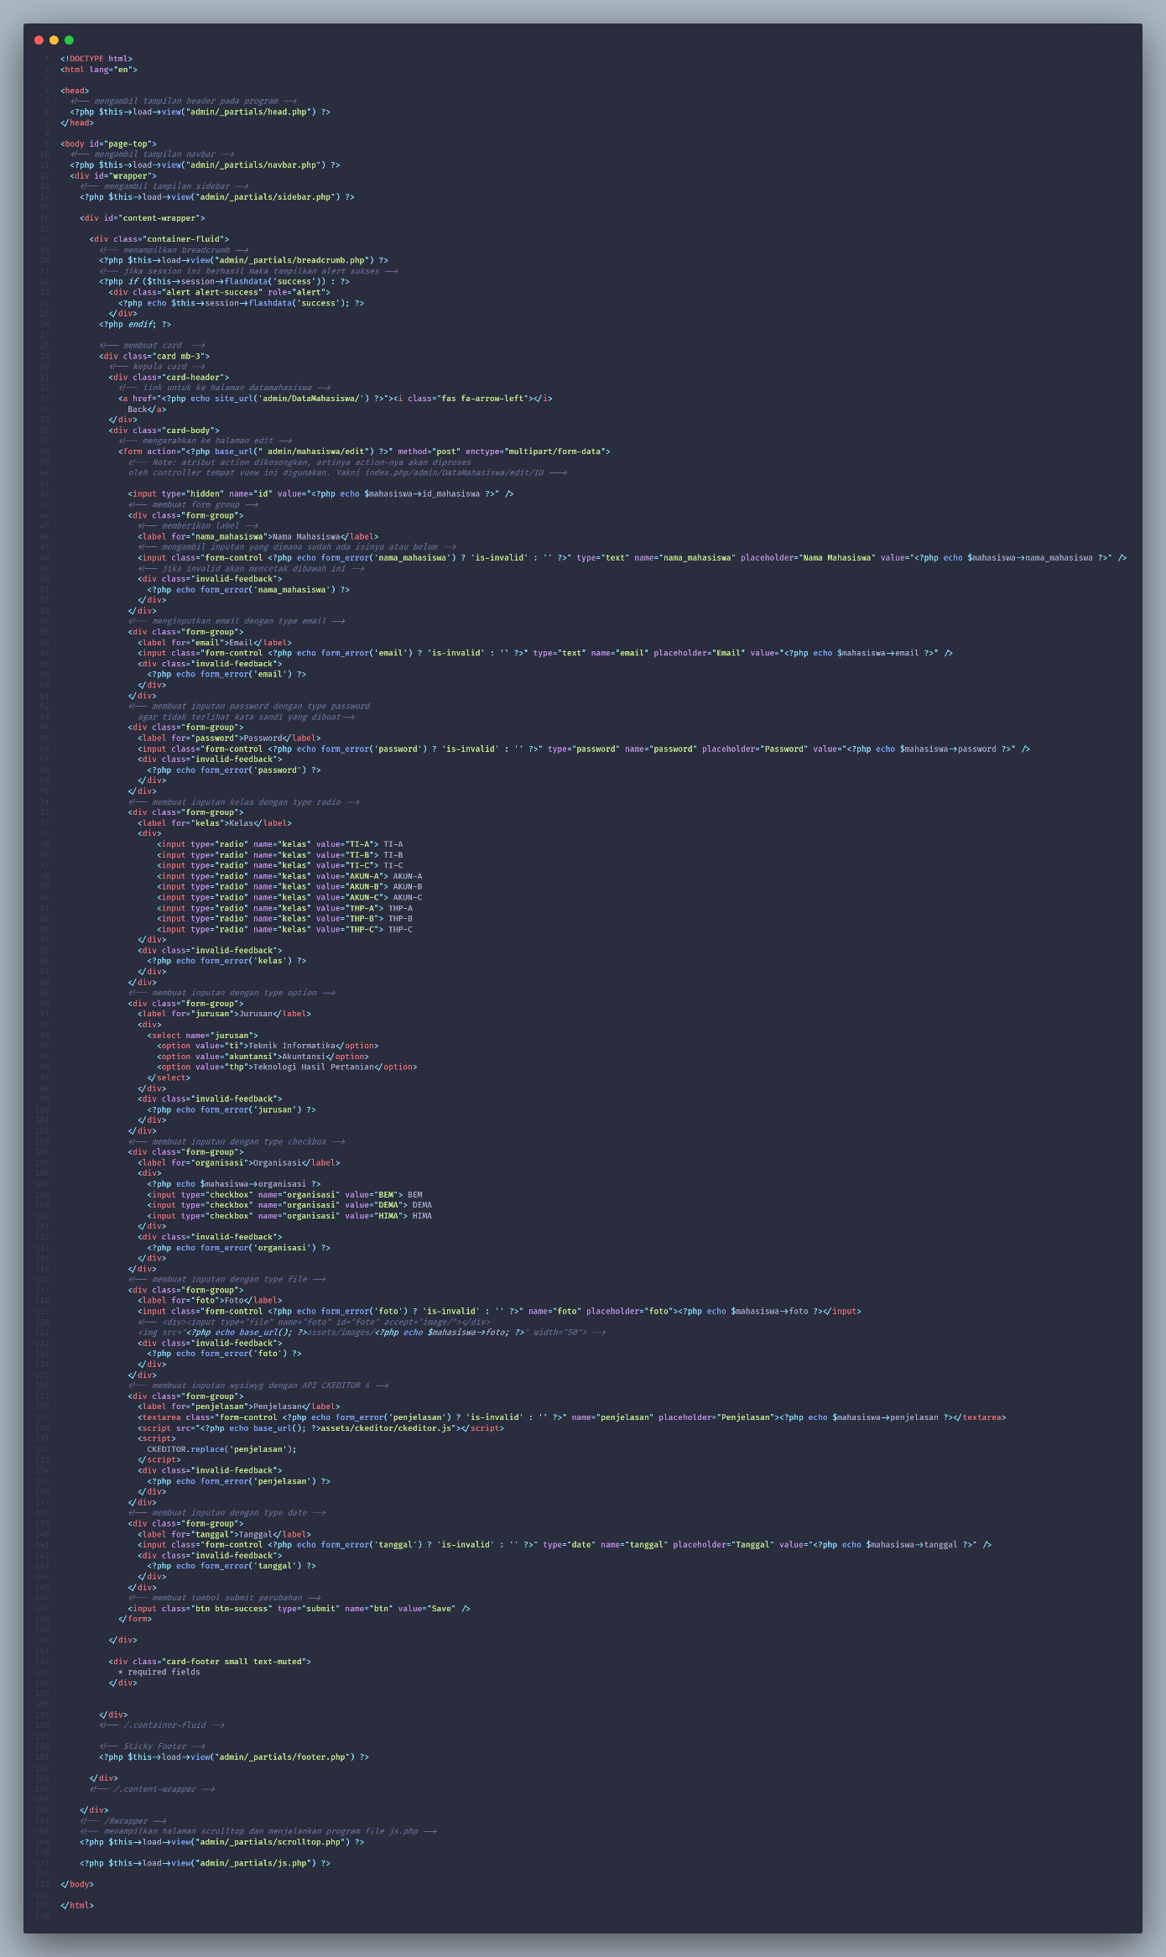

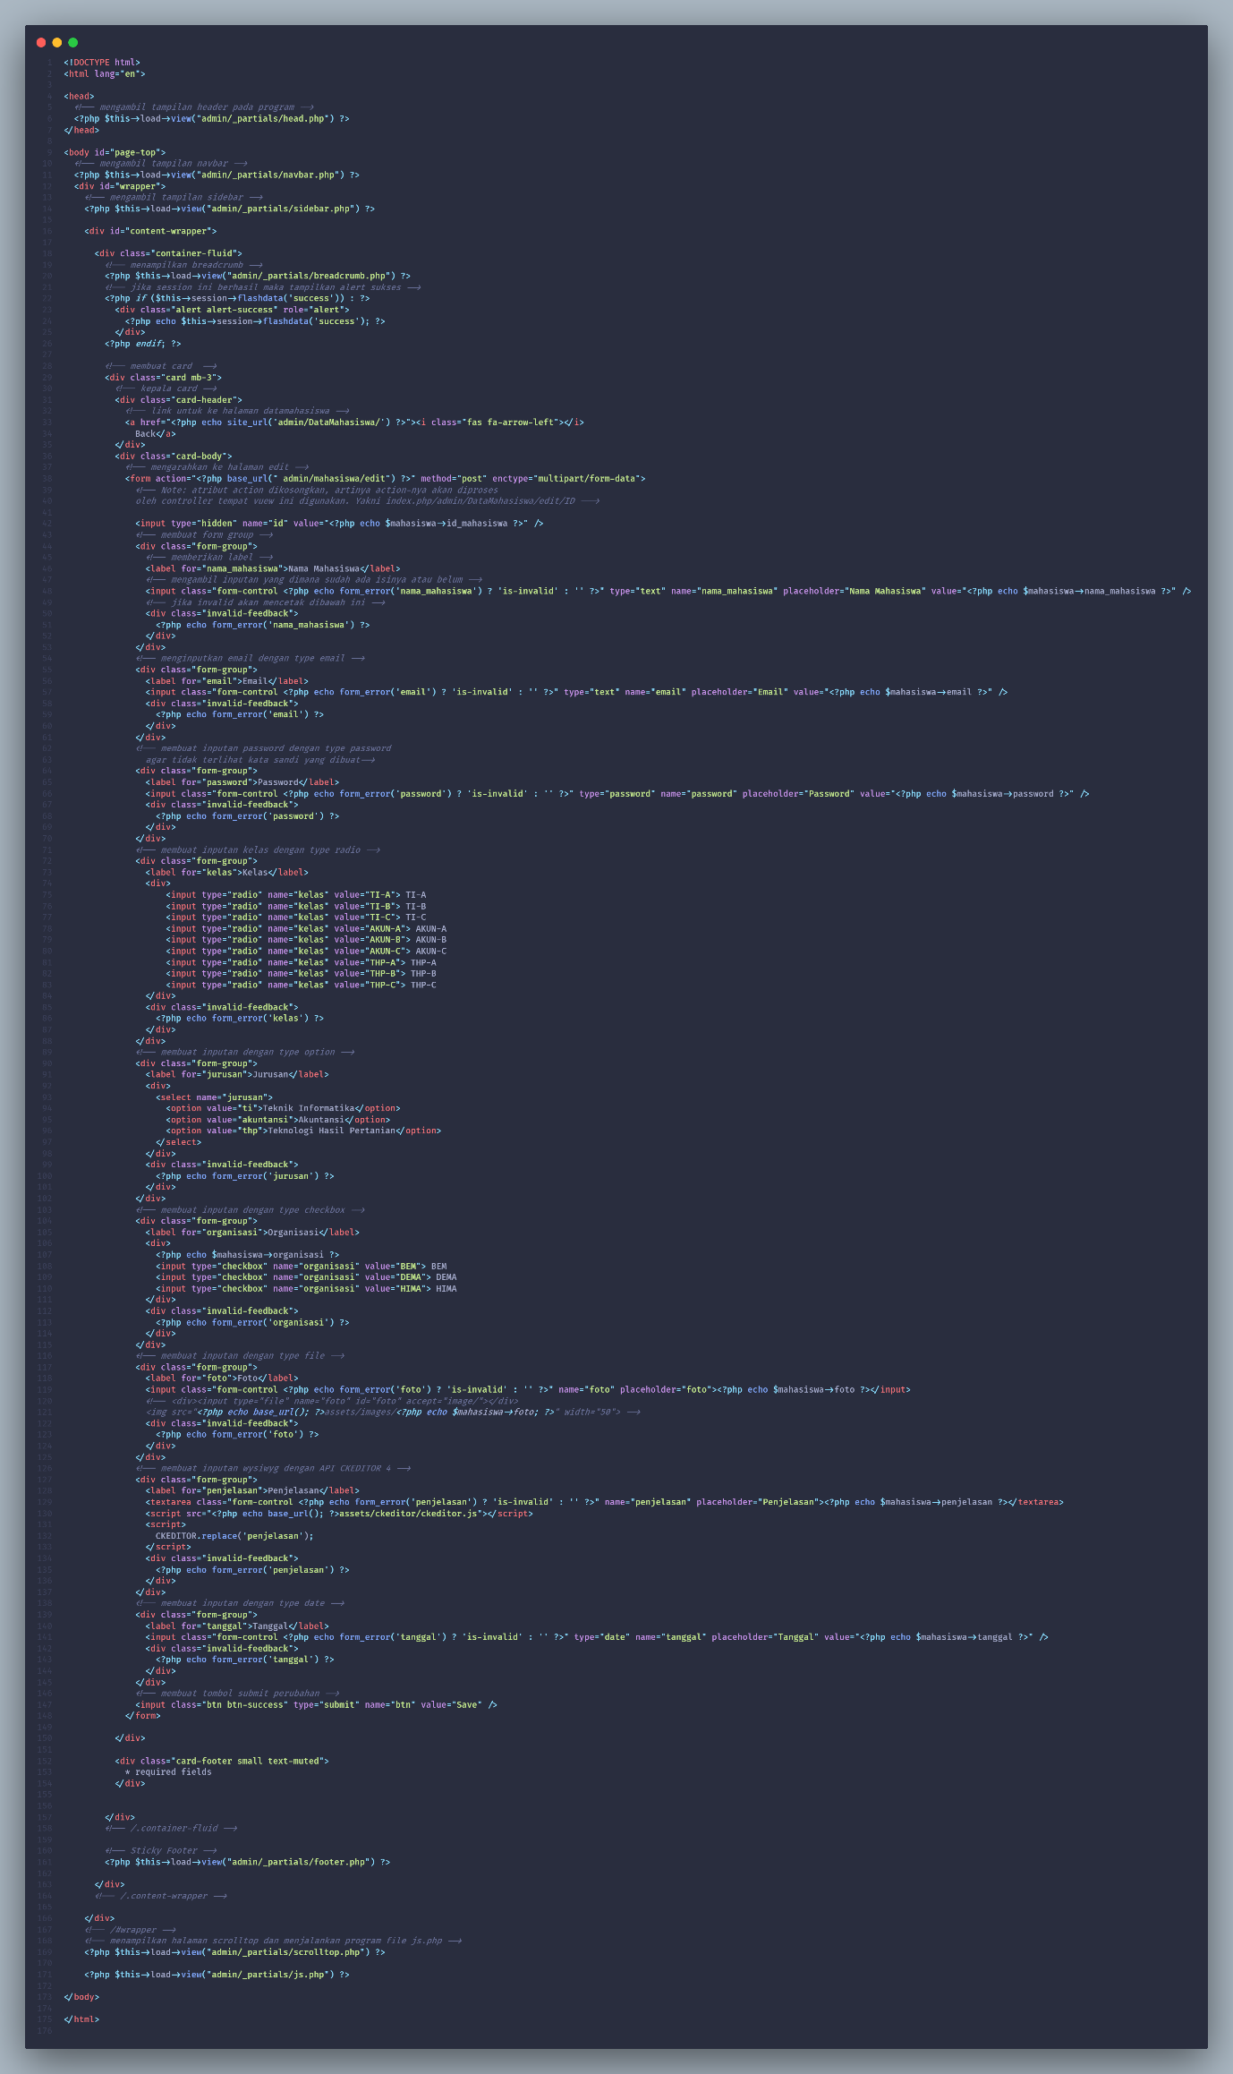

Application/controllers/admin/DataMahasiswa.php

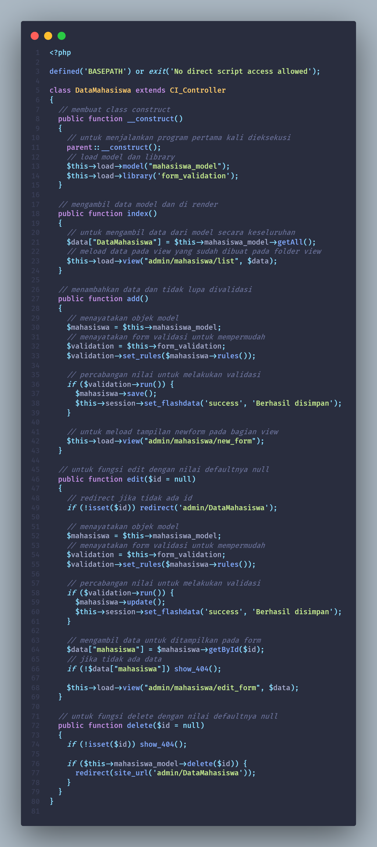



Application/models/Mahasiswa_model.php

